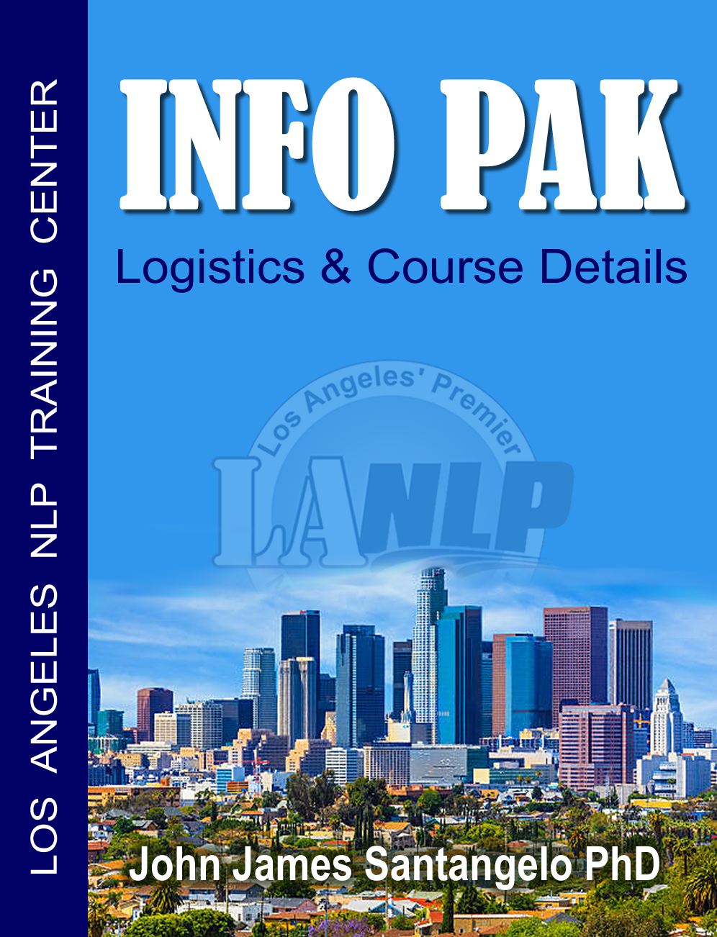
THANK YOU for inquiring about our NLP Practitioner Courses!
I’m sure you have many questions about WHAT this is all about, WHAT you’re going to learn with us, WHERE we’re hosting our event, maybe even WHY you’re even interested in getting certified as an NLP Practitioner, yes?
There are many reasons why amazing individuals like yourself take a course like this.
In the beginning I think everyone attends for most of the same reasons, such as;
“I want to, over-all, improve my life.”
“I want to better my relationship skills, or begin one!”
“I’d like to become a better sales person, influencer or communicator.”
“I’d like to learn to get out of my own way more often so I can actually get what I want!”

Here are some of the same reasons: “ I “ attended my first NLP Practitioner program.
I wanted more clarity in my own life, find my passion, stop the sabotage and produce the results I wanted more often. Does any of this sound familiar? Your reasons may be different, but your results will be the same as all our graduates; it’s the ability to control your emotions, make empowering decisions and take action every single day to get the results YOU want!

Let me ask you this very important question; WHERE did you learn your communication, relationship and financial skills? Well, if you’re like most people; you’re parents! But I bet no matter how awesome they were, they lacked certain skills that you now would like to have along your path in life, yes? You see, in NLP we have a couple sayings or beliefs; “Everyone is doing the very best they can with the limited resources they have.” and another powerful one which changed my life and the way I interact with myself and others is; “There is no FAILURE, only FEEDBACK.” This one single statement, once I began operating from, CHANGED MY LIFE!

How could it not? For most people, we constantly feel bad for something that’s just a ‘result’ in our lives, it’s just a result, just NOT the one we intended. So now when I DO SOMETHING it’s all about WHAT I’ve learned. Cool, right? Image if you looked at EVERYTHING you do from now on as a result and what you can learn from it... your life would never be the same again.

With this course, we spend the majority of our time helping you get real clear about what exactly you want from life, AND helping you remove the roadblocks/obstacles which get in your way.

WHEN: Every Feb & Sept. - http://lanlp.com/nlp-trainings
WHERE: Agoura Hills, CA. Google Map Here
WHAT: Normally $2,995. Check here for your special discount - Register Here!

Here’s to your success, John

What Is NLP - Neuro-Linguistic Programming?
“What is NLP?” is a bit like asking, “What is Gravity?” because there are so many possible ways to answer it. One answer is that NLP is able to accomplish what the beginnings of psychology promised a hundred years ago, and never quite delivered—a practical way of understanding our thinking and our behavior that can be used to make rapid and useful changes in our lives. Another answer is that it is the study of the structure of subjective experience, the inner workings of our minds, and how to use that knowledge to enrich our choices. Much of this structure is typically unconscious, or preconscious. However much of this structure can become conscious, altered, and then allowed to become unconscious and automatic again.

Someone once described NLP as “Cognitive Behavioral Therapy on steroids” because although it is fundamentally similar in orientation, NLP makes much finer distinctions and has many specific processes, principles, and presuppositions that make change much faster.

Yet another description is that it is a collection of methods for achieving specific personal outcomes, along with a common understanding of how they all work, which can be used to develop new methods. NLP is sometimes described as a pragmatic methodology for modeling human excellence that can be applied to any context or any area of your life. Once modeled, anyone can learn the model in order to learn the skill, an example of a much-overused term, “accelerated learning.”

Someone once pointed said, “The human brain is the only self-maintaining, general purpose computer that can be manufactured by unskilled labor.” It is also the only computer that is only partially programmed at the factory and doesn’t come with an operating manual. A child’s brain doesn’t have the kinds of programs that we have as adults, and there are no instructions about the operating system, or how to program it to its maximal efficiency.

Although there is still some disagreement about exactly what kind of computer the brain is, it is clear that we input information through our five senses, process it in a variety of ways, using our ability to remember, forecast, connect different experiences, and generalize about them, and then output behavior and results. Our output of behavior and responses then become additional inputs to be processed, in a never-ending cybernetic process loop.

Since we have no operating manual, and no keyboard each of us essentially had to program ourselves, despite the best efforts of our parents, much of our programming was somewhat random, and was often the result of accidental events, some supportive and some traumatic. Much of our programming operates reasonably well, while other parts don’t work well at all.

So another definition of NLP is that it is an operating manual for the human brain, providing “software for our hardware,” that can be used to reprogram ourselves when we are less than fully satisfied with our results.

Hey, my Mom still doesn’t understand what I do! ;-)
I’d love to hear from you (818) 879-2000

Six Reasons To Take Our NLP Training

1. Real-World Experience
We bring decades of REAL-WORLD corporate and clinical "in-the-trenches" work experience to your NLP training. This benefits you because you'll find most trainers have NO real-world experience whatsoever. LANLP offers you the expertise from an experienced professional speaker & trainer in the speaking business. John works closely with each student making sure you receive the very best learning experience.

2. Convenience To Learn
We work around YOUR schedule! Our program is designed so you'll become certified over the course of SIX weekends, so you’ll have a life and take only the necessary time off to get certified with us.

3. Full Integration of Material
Because you're training on the weekends, it gives you plenty of time to practice and integrate the information in between classes, form out-of-class study with fellow students during the week to learn at a deeper level. Many students have experienced that the short/advanced courses which other companies offer are leaving them with no real practical memory or benefits of the traditional pure 12-day, 120-hr program. Don't be fooled by other courses giving you reasons why they cannot give you the traditional 12-day 120-hrs of face-to-face time with the trainers.

4. Enhance Business Performance
With our NLP training course, you will be able to influence others, increase sales, learn leadership, coaching, and management skills. Taking an NLP training is best suited for anyone wanting to influence others, Coaches, Educators, Salespeople, Managers, Speakers, Marketing Professionals, Human Resources and Corporate Trainers.

5. Develop Professional Coaching & Therapeutic Practices
Our NLP training will help you with setting goals, communication mastery, techniques for motivation, resolving fears and phobias, spelling and deep love strategies, weight loss and smoking-cessation techniques. You'll discover the mastery of communication, help resolve deep rooted issues, habits and addiction, and moving people to empower themselves to resourceful states.
6. Further Self-Improvement Skills
Some people decide to take an NLP training course simply to develop their PERSONAL POWER! And others come because they have heard that NLP can help with certain big issues very fast. Our NLP training can help with a fear of public speaking, motivation, weight loss, insecurity, and getting your goals! This course gives you a mastery of communication to influence yourself as well as others!

1. Name the top 3 goals you’ll achieve because of this 12-day NLP training course?
2. What prevents you from producing those results in your life right now?
3. How have you tried to resolve this issue in your life before?

How Can Our NLP Training Help You?
NLP provides an amazing set of skills and discoveries about how we think, cope, learn, and communicate with ourselves and others for success. what-ever success means to you. Learning NLP principles and models will help you create better relationships, change limiting beliefs and be more successful at whatever you want to do. How is this possible? Because NLP offers you a variety of practical ways to help you create the future that you want for yourself, while clearing out the unconscious blocks that keep you from being your best self.

Your next opportunity to learn and experience these powerful methods for changing your life begins on the first day of your NLP Practitioner Certification training program. And we've made it as easy as possible for you to attend the program this year, because it’s conveniently held for 6 consecutive weekends, so you can have a life and train with us just on the weekends. We also have several interest-free tuition payments plans that can be spread out over time to make it even easier for you to attend this life-changing event.

Click here for more information about the training course and details.

During the course, you will learn how to get in rapport quickly (even with difficult people), deal more effectively with emotionally challenging situations, and be more in control of your life. You will also learn how to consistently create the results you want throughout your personal and professional life. Something we all aspire to do!

You might be asking yourself if this training course is for you... the answer is yes! Whether you’re a business professional or on a personal development journey, I promise you you’ll gain the necessary skills to get more of what you want and to be more effective at whatever you do.

You are also protected by our 100% money-back guarantee.

You just can't lose with this money back guarantee - Here's how it works: Come and attend the first full day of the NLP practitioner training. If you decide that the training isn't for you (for any reason), just let us know by the end of Day 1, and we'll refund 100% of your investment (minus a $100. paperwork registration fee). No questions asked.

How can we afford to be so generous? Easy. So far every single person who has started the NLP Practitioner Certification has reported phenomenal value and experienced amazing results, has tested and graduated as an NLP practitioner. So we’re very confident you will too!

It's easy to get started, just pick up the phone now and call me personally (818) 879-2000 to ask any further questions and/or to register for our next upcoming course. You can always contact me directly with any further questions.

We hope to see you at our next NLP training. I know you’ll look back and say;
“That was the most FUN and valuable experience I’ve EVER HAD!“
But don’t take my word for it, decide for yourself, it’s guaranteed.

PS – below, I’ve put together a couple exercises for you to do... have fun!
Playing With Your Brain?
Recall a pleasant experience from your past. As various things may pop into your mind, just allow yourself to go with some pleasurable memory for the moment. As you experience this pleasant memory, notice its visual aspects. What do you see? Notice the images. Now make the picture larger. Let it double in size... and then let it double again... Notice what happens. Do your emotions intensify?
Now shrink the picture. Make it smaller and smaller. Allow it to become so small you can hardly see it... Stay with that a moment... Does the intensity of the feelings decrease? Experiment again with making the picture bigger and then smaller. When you make it smaller, do your feelings decrease? And when you make it larger, do your feelings increase? If so, then running the pictures (sounds, feelings) in your awareness in this way functions as it does for most people. However, you may have a different experience. Did you? It's all good! We all code our experiences in our minds uniquely and individually. Now, put your picture of that experience back to where you find it most comfortable and acceptable.
As you maintain the same picture, move the picture closer to you. Just imagine that the picture begins to move closer and closer to you, and notice that it will. What happens to your feelings as it does? ... Move the picture farther away. What happens when you move the picture farther away? Do your feelings intensify when you move the picture closer? Do your feelings decrease when you move the picture farther away? Notice that as you change the mental representation in your mind of the experience, your feelings change. This describes how we can "distance" ourselves from experiences, does it not?
Now experiment with the color. Are your pictures in color or in black-and-white? If your pictures have color, make them black-and-white, and vice versa if you have them coded as black-and-white . . . When you changed the color, do your feelings change? Are they in focus or out of focus? Do you see an image of yourself in the picture or do you experience the scene as if looking out of your own eyes? What about the quality of your images: in three-dimensional (3D) form or flat (2D)? Does it have a frame around it or do you experience it as panoramic, like an IMAX? Change the location of the picture. If you have it coded as on your right, then move it to your left. What happens?
The neat thing about playing with our brains in that way is that as we change our coding, therefore we can change our feelings about any particular event, image that? The neurology of our emotions responded to the linguistics (or symbols) of our brain. When we change various features of our representations, it affects our emotional responses.
This describes, in part, how "the magic" of NLP works. As we work with the very structures and processes of HOW we represent experiences, rather than content, we change the programming. And when you know the structure of experience, you can use that knowledge to create more generative processes for improving life all around. What would happen if you made all your unpleasant pictures small, dim, and far away? What would happen if you made all your pleasant experiences big, bright and up close? TRY IT! Have fun with this new learning.
Well - Formed Outcomes
Take this 8-step process and run your goal(s) through and notice how they happen faster.
Get out a piece of paper and let's start with just ONE of your goals; a simple, one-year goal.
1) State the goal in positive terms.
- Describe the Present Situation and compare it with the desired future goal.
- Where are you now? and where do you want to be?
- What do you want?
- State it in the positive (what you want to achieve.
2) Specify the goal in Sensory Based Terms.
- What will you see, hear, feel, etc., when you have it?
- What steps or stages are involved in reaching this goal?
- Have you broken down your goal into small enough chunks so that each is do-able?
- What are the sizes of the behavioral chunks? Could the size possibly overwhelm you?
3) Specify the goal in a way that you find compelling.
- Is the goal compelling? Does it pull on you? Make it a compelling future representation that is dissociated (When you see your goal make sure you see yourself having obtained it).
4) Do Quality Control check on your Goal to make sure it is for you in all areas of life.
- Is the desired goal right for you in all circumstances of your life?
- What will having your goal give you that you do not now have?
- What will having your goal cause you to lose?
- Is your goal achievable? "Are there any parts of me that objects to actualizing this goal?" If so, pay attention to how your whole-self responds in terms of sensations within you.
5) Self-initiated and maintained.
- Is the goal something that you can initiate yourself and maintain?
Is something that you have within your power or ability to do.
- Is it within your control?
Your goal must be something that you can initiate and maintain. It must not be something dependent on other people.
6) State the Context of the goal.
- Where, when, how, with whom, etc. will you get this goal?
- Is the goal appropriately contextualized?
Test your goal by applying it to a context: when, where, with who, etc.
7) State the Resources needed to achieve the goal.
- What resources will you need in order to get this goal?
- Who will you have to become?
- What prevents you from moving toward it and attaining it now?
8) Evidence Procedure.
- How will you know that your goal has been realized?
- What will let you know that you have attained that desired state?

Representational System Test

For each of the following statements, place a number next to each phrase.
Make sure to use one number for each blank line to indicate your preference:
4 = Closest to describing you
3 = Next best description
2 = Next best
1 = Least descriptive of you

1. I make important decisions based on:

___gut level feelings.
___which way sounds the best.
___What looks best to me.
___precise review and study of the issues.

2. During an argument, I am most likely to be influenced by:

___the other person's tone of voice.
___whether or not I can see the other person's argument.
___the logic of the other person's argument.
___whether or not I feel I am in touch with the other person's true feelings.

3. I most easily communicate what is going on with me by:

___the way I dress and look
___the feelings I share.
___the words I choose.
___the tone of my voice.

4. It is easiest for me to:

___find the ideal volume and tuning on a stereo system. .
___select the most intellectually relevant point about an interesting subject.
___select the most comfortable furniture.
___select rich, attractive color combinations.

5. (no question, just answer)
___I'm very attuned to sounds of my surroundings.
___I am adept at making sense of new facts and data.
___I am very sensitive to the wav articles of clothing feel on my body.
___I have a strong response to colors and to the way a room looks.

Scoring Representational Preferences

STEP ONE: Copy your answers from the previous page to the lines below:

- ____ K 2. ____ A 3. ____ V 4. ____ A 5. ____ A
____ A ____ V ____ K ____ D ____ D
____ V ____ D ____ D ____ K ____ K
____ D ____ K ____ A ____ V ____ V

STEP TWO: Transfer the numbers for each statement to the appropriate representational system column in the table below.

Table | V | K | A | D
1.
2.
3.
4.
5.
Totals | = V | =K | = A | = D

STEP THREE: Add the columns and write the totals in the space provided in the table above. The comparison of the total scores gives the relative preference for each of the four major representational systems.

V = Visual
K = Kinesthetic
A = Auditory
D = Auditory/Digital

Hope you enjoy these processes (there’s plenty more empowering exercises in class).
Please contact me about our $1,000. Discount, or our 2-for-1 offer. info@LANLP.com

Here’s to your success, John
Please contact me directly – (818) 879-2000 / info@LANLP.com

